**Setting Up Eclipse Development Environment – Lecture 2 – Mon Aug 23 or Tues Aug 24**

**Development Environment**

**Deciding on a Development Environment**

* You can use other environments – ChIDE, Virtual Studio IDE, NetBeans
* I believe all these are supported on PC and Mac
  + Eclipse – shown in these notes
  + ChIDE
    - <https://www.softintegration.com/docs/ch/chide/>
    - click Downloads tab
    - click “Download Now!” button
    - Register
    - Login and download productfor your OS
  + Visual Studio IDE
    - The **community version** is free to download
    - <https://www.visualstudio.com/>
  + NetBeans
    - https://netbeans.org/
* All IDE’s have their pros and cons, so pick one and stick with it so you will figure out its idiosyncrasies the more you use it.
* I’m using the Eclipse IDE and will be demonstrating code in class using Eclipse. If you have problems with Eclipse I can probably be more helpful than if you have problems with the other IDE’s.

**Setting up Eclipse Development Environment on Personal Computer**

**Need three things to write C programs using Eclipse**

1. Java Runtime Environment
   1. Eclipse is a Java based IDE so 1st thing we need to do is install the JDK
2. Eclipse with CDT (C Development Tools)
   1. You can set up Eclipse so you can use it for Java, C, or both Java and C
3. GNU Complier gcc

**Important Note for Java Students:**

* If you already have eclipse you already have Java JDK
* Skip to Step 6: Download GCC compiler

**Step 1: Download JDK (Java SE Development Kit)**

* Google “JDK”
  + Should see link- **Java SE – Downloads | Oracle Technology Network**
  + You could also enter:

<http://www.oracle.com/technetwork/java/javase/downloads/index-jsp-138363.html>

* Click the big Java icon under the Java SE Downloads title or the download button under JDK

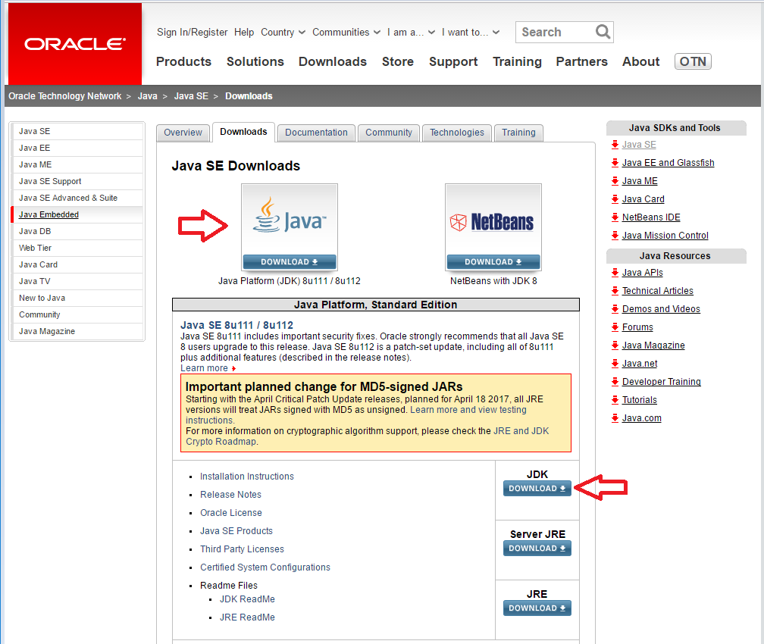

* You should now see the **Java SE Development Kit 8 Downloads** page shown below
* The kit number will most likely be different but that is of no concern
* Under the Java SE Development Kit find the kit for your operating system
  + Windows x64 (64 bit) or
  + Mac OS X

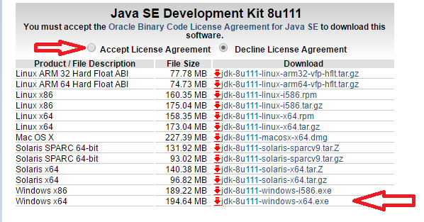

* Make sure you accept the license agreement
* Click the link to download
* If using Chrome, in the lower-left corner, you will see the download status

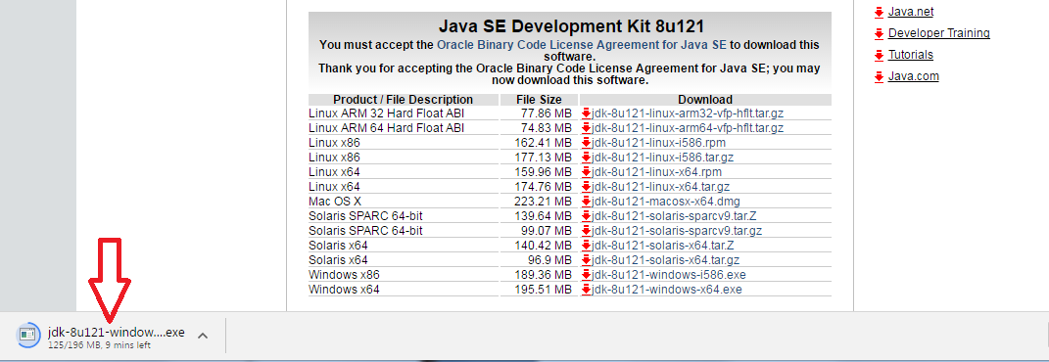

* The **JDK’s executable** file will download into the browser’s **default download location**
  + Default download location is the “downloads” folder in your “user” account
    - On my personal computer, this is C:\Users\mickeyg\Downloads
  + In Chrome, you can find out where the download location is by:
    - Clicking the Chrome menu button (three horizontal dots) in the upper-right corner of the Chrome window
    - Select “Settings” from the menu
    - Settings will be displayed in a new tab
    - Scroll down to the “Show advanced settings…” link and click it
    - Scroll down to “Downloads”
  + If you prefer, you can set up your browser to save downloads to a different location.

**Step 2: Install JDK**

* Once the download completes, start the installation by double clicking on the downloaded .exe file in the browser.

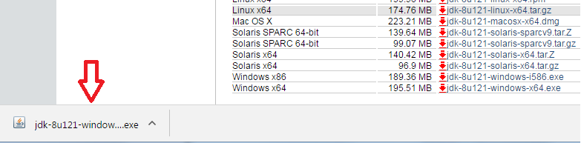

* Note: If you're running on an older computer it may take a few minutes for the installation to get started.
* In Windows, you will see the **Welcome** dialog – click **Next** to start download

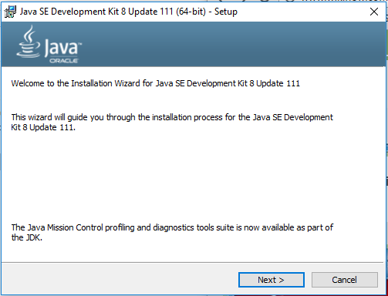

* The next dialog offers some options – click **Next**.
  + Notice that the JDK will be installed in the **Program Files** directory (for Mac it's the **System - Library** directory)
  + This is where it should be installed so don’t change the location

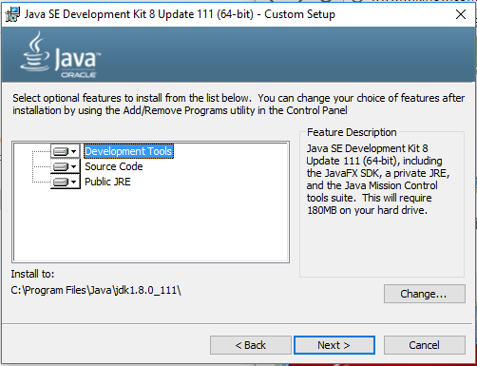

* A status window will start showing the status of the install.
  + Note: When I did the install, the status window came up but it never showed any status. When I looked in the **C:\Program Files** directory (the location for the Java installation) I saw that I had a **Java** directory and it contained the **JDK and JRE file**s. I never saw any status but eventually – several minutes later – I saw the successfully installed screen.

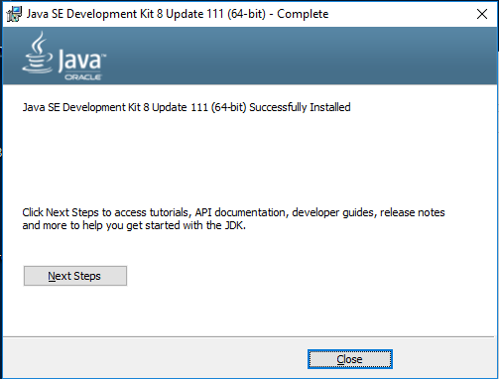

* You’re now set to use the JDK

**Step 3: Download Eclipse**

* Note: you can **combine language support** into any of the default packages
* I’m going to start with the **Java IDE** and then add in support for C/C++
* If you want **only** C/C++ scroll down to the section “Setup your environment for **only C/C++**”
* To setup your environment for both **Java and C/C++**
  + Go to: <http://www.eclipse.org/downloads/eclipse-packages/>
  + Select **Eclipse IDE for Java EE Developers**

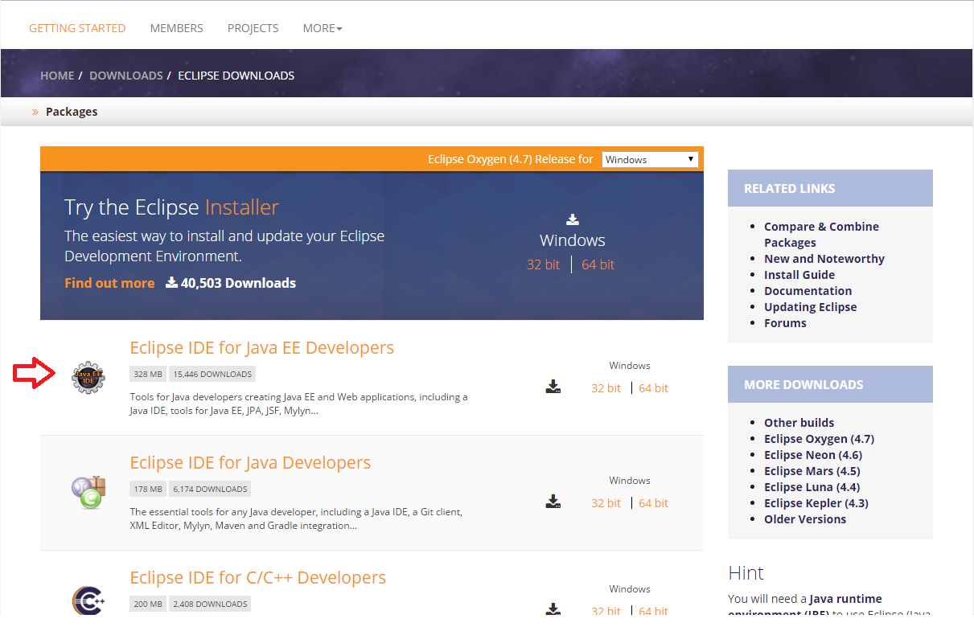

* + On the left-hand side, under **Releases** click “Oxygen”
  + On the next page, you will see the available Oxygen packages

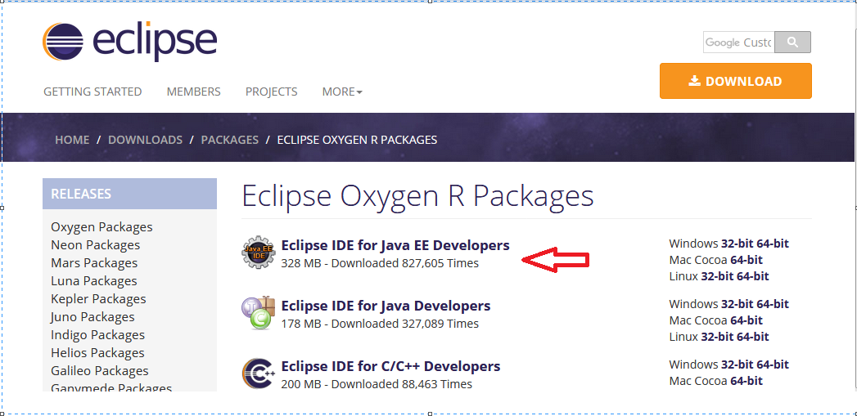

* + To the right of **Eclipse IDE for Java Developers**, click “Windows 64-bit” or the link appropriate for your system
  + You should end up on a page with a big download button - click that button!

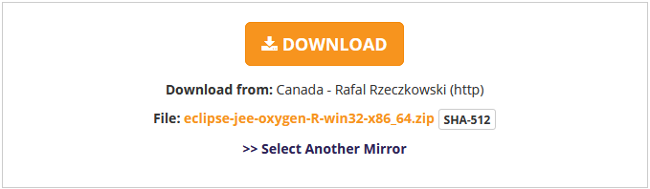

* Setup yo**ur environment for only C/C++**
  + Go to: <http://www.eclipse.org/downloads/eclipse-packages/>
  + Select **Eclipse IDE for C/C++ Developers**

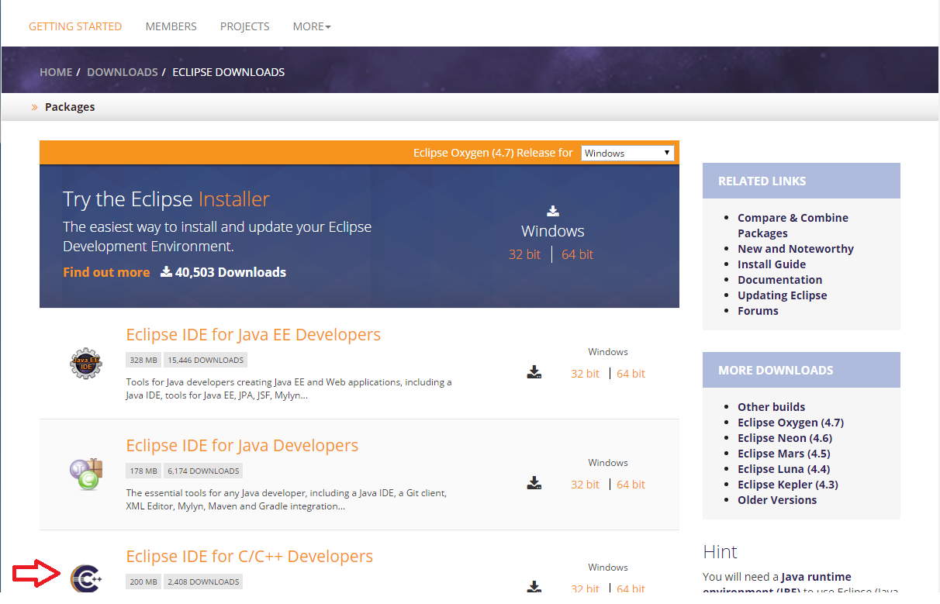

* + On the left-hand side, under **Releases** click “Oxygen”
  + On the next page, you will see the available Oxygen packages

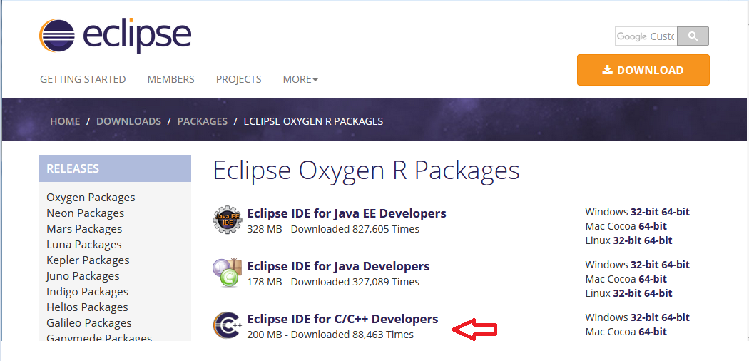

* + To the right of **Eclipse IDE for C/C++ Developers**, click “Windows 64-bit” or the link appropriate for your system
  + You should end up on a page with a big download button - click that button!

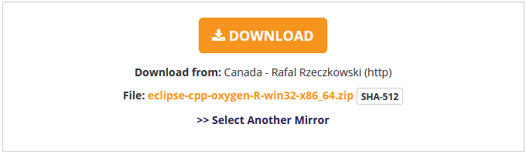

* The **Eclipse zip** file will download into the **default download location** (“download” folder in your “user” account) unless you have set up your browser to save to a different location.

**Step 4: Extract the Eclipse files to directory of your choice**

* Eclipse is a bit different since you don’t actually “install” it – instead - because it is a zip file and you **extract** it to a directory of your choice.
* Locate the eclipse zip file in the directory it was saved
  + If you don't know where that is, in Chrome, click the down arrow on the download then select “Show in folder.”

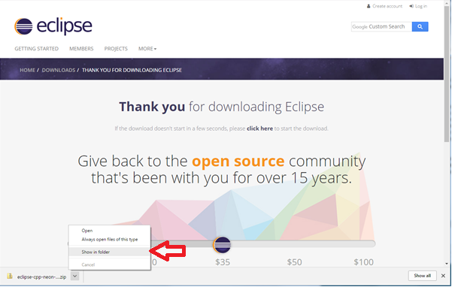

* Right click on the Eclipse zip file and select “Extract all”
* The “**Select a Destination and Extract Files**” dialog will be displayed
* In that dialog, select where to place Eclipse – see next bullet for some guidance on location

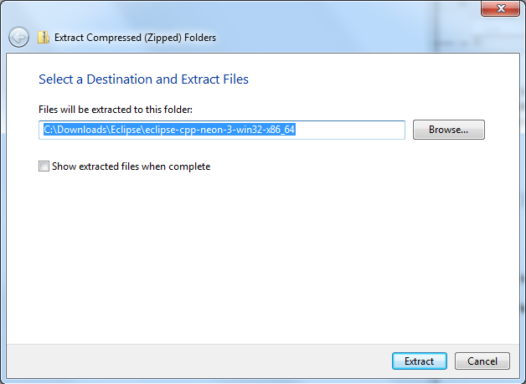

* Own my personal systems, my preference is to create a "**Dev**" directory on my C drive and unzip Eclipse there - **C:\Dev**
* **NOTE: Do not place the eclipse file too deep into file structure it causes an error**

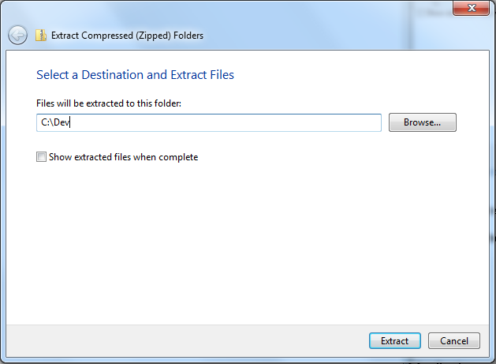

* Once the unzip completes, go to the location you selected and view all the files (on my system that would be **c:\Dev\eclipse**).
* Note: if you ever need to uninstall Eclipse, just delete the eclipse directory and workspace.

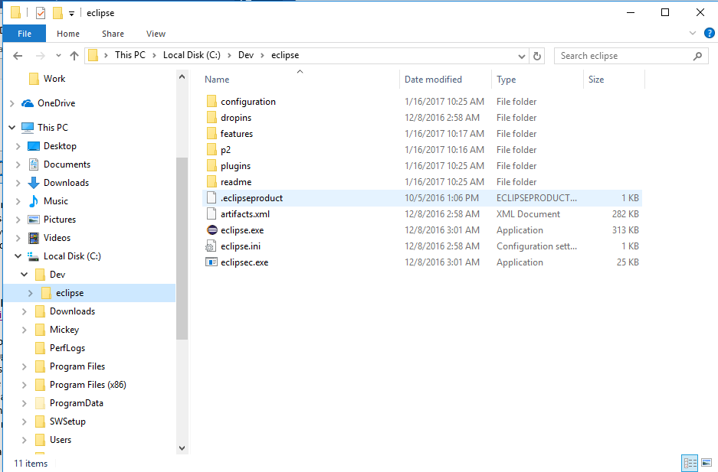

**Step 5: Start Eclipse**

* Double click the **eclipse.exe** file (you may not see the **.exe** file extension – it’s the file with the round purple icon)
* Eclipse will ask you where you want your workspace -- C:\Users\mickeyg\workspace

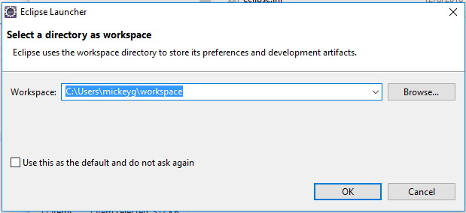

* + - I like to change my workspace to use my “**Dev**” directory -- C:\Dev\eclipse_workspace

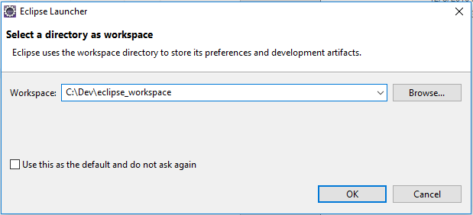

* When done, my “**Dev**” directory looks like this – it contains the **eclipse** and **eclipse_workspace** directories

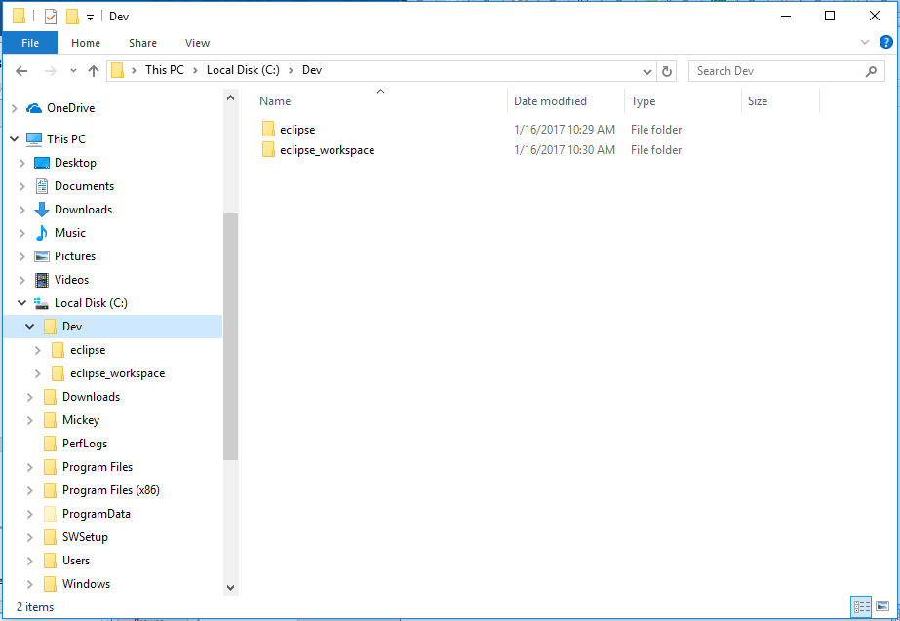

You should be setup now to create, compile and run **Java** programs but not **C** programs!

More needs to be done to setup environment to run **C** programs.

**Step 6: Download GCC compiler**

* This is the needed to compile C/C++ programs
* GCC used to stand for the GNU C Compiler, but since the compiler supports several other languages aside from C, it now stands for the GNU Compiler Collection.
* MinGW stands for "Minimalist GNU for Windows"
  + It is essentially a tool set that includes some GNU software, including a port of GCC.
* Go to <https://sourceforge.net/projects/mingw/>
* Click on download button to download **mingw-get-setup.exe**

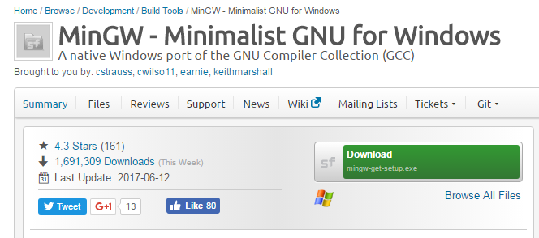

* If using Chrome, in the lower-left corner, you will see the download status
* Once the download completes, start the installation by double clicking on the downloaded .exe file in the browser.

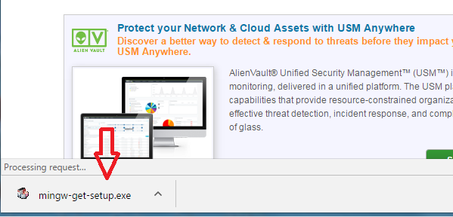

* The following window will be displayed to install MinGW
* Click install

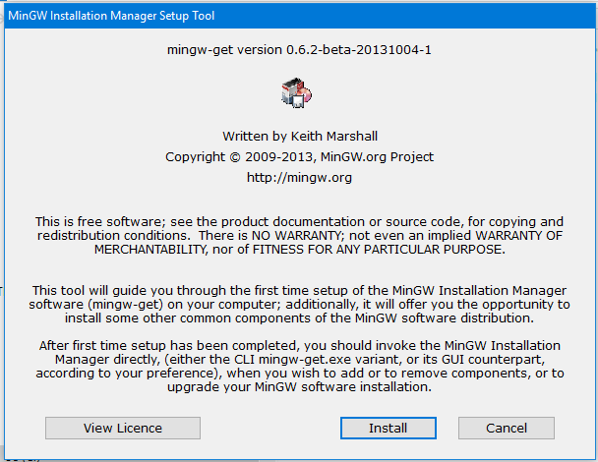

* On this next screen, make sure the installation directory id C:\MinGW
* Then click continue

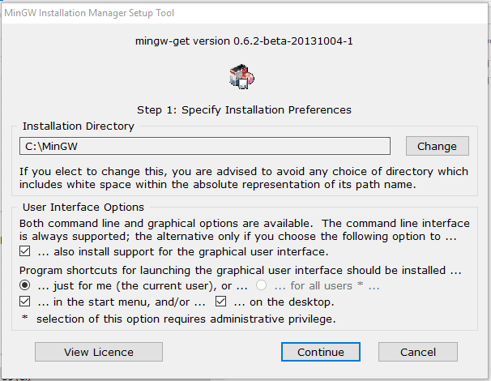

* You will see a window showing the files being installed
* This is an on-line installer so it will take a little bit to download the files

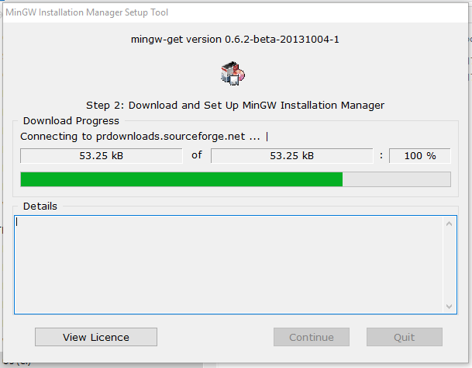

* When the installation has completed, the Continue button will be enabled
* Click Continue

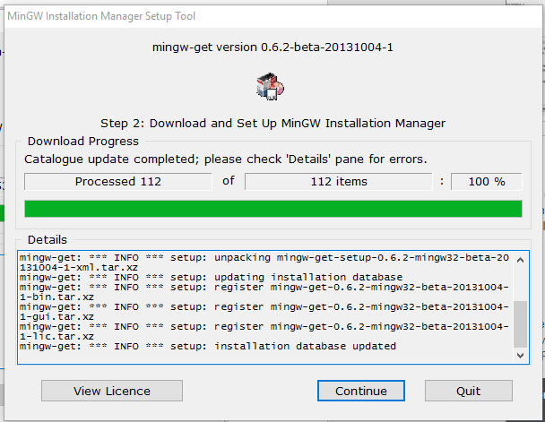

* The MinGW Installation Manager will be displayed.
* You need to make a couple selections in the manager:
  + In the left window, select Basic Setup
  + In the right window, select
    - mingw32-base (contained the C compiler/linker, etc.)
    - mingw32-gcc g++ (in case you want to do C++ in the future)
    - Note, to select these options, click on checkbox and select “mark for installation”
* When items are checked, select **Installation** from menu and then **Apply changes**

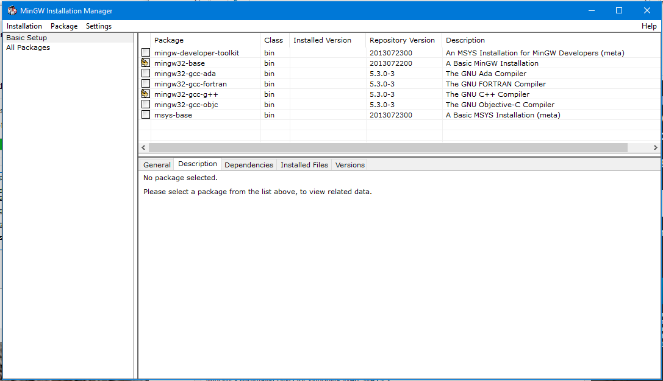

* Click Apply to start the installation of selected items

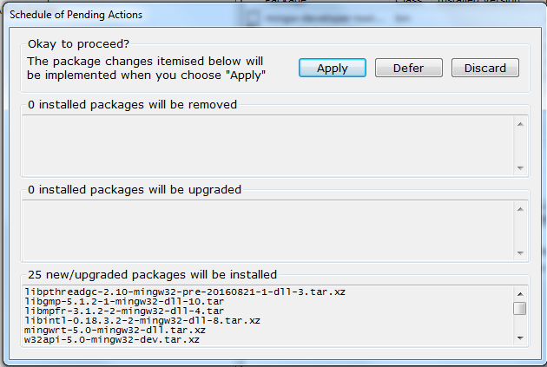

* When installation is complete, click the Close button
* Go to the **C:\MinGW\bin** directory and you will see a bunch of .exe files

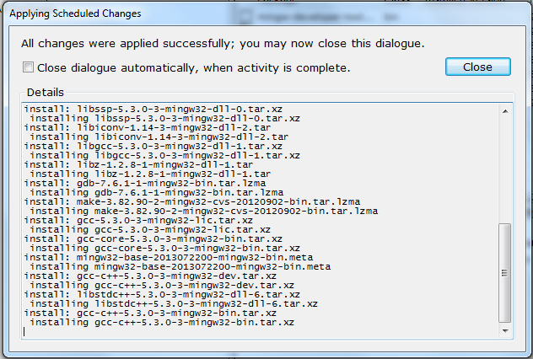

**Step 7: Configure Eclipse to work with C/C++**

**NOTE:** Do this step **ONLY** if you installed the **Eclipse IDE for Java EE Developers**

**SKIP** this step if you installed the **Eclipse IDE for C/C++ Developers**

* If you installed **Eclipse IDE for Java EE Developers** youneed to install CDT (C/C++ Development Tools) to write programs in C.
* Browse to <https://projects.eclipse.org/projects/tools.cdt>
  + You will see link to **Eclipse C/C++ Development Tooling (CDT) | projects.eclipse.ord**
  + You could also enter: <https://projects.eclipse.org/projects/tools.cdt>
* Click on the Downloads tab

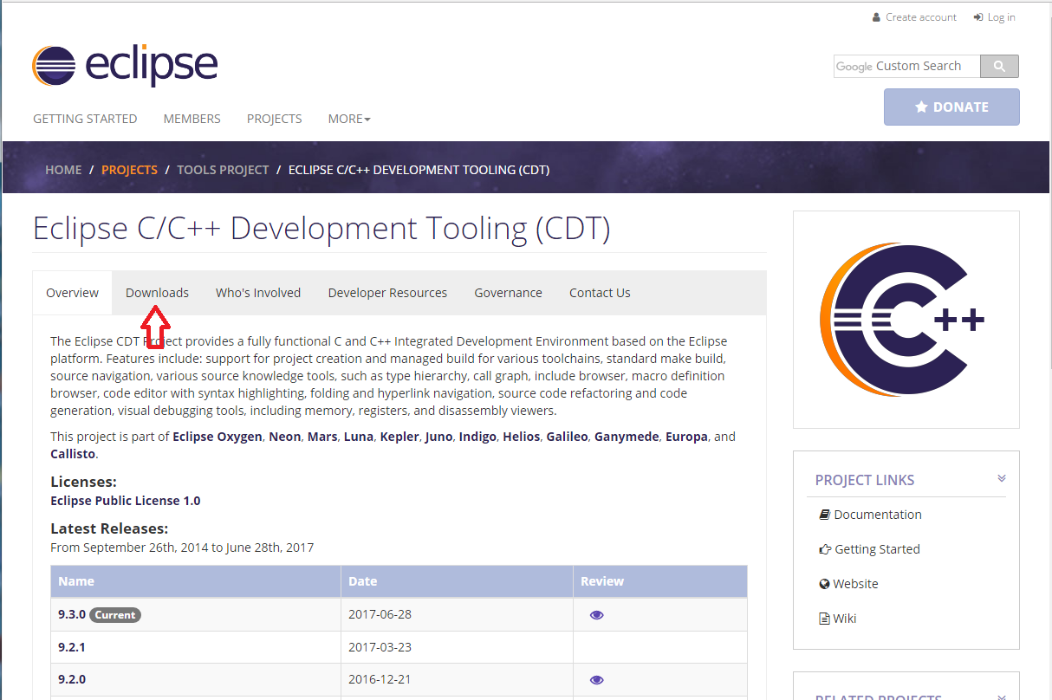

* On this page find the latest CDT for your version of Eclipse
* We will be doing the next steps from within Eclipse so what you need from this page is to **COPY the link** in the **p2 software repository** (see red arrow below)

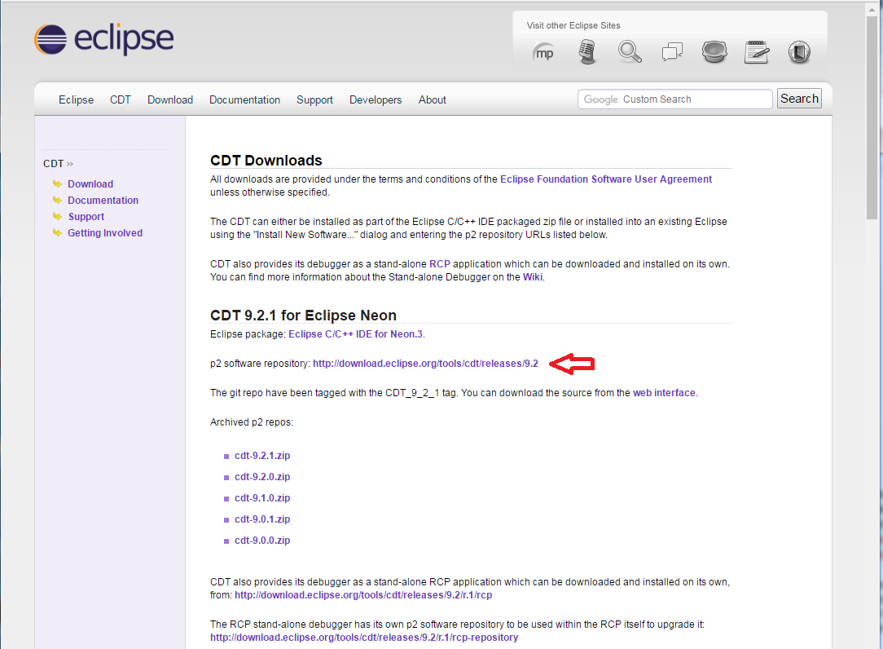

* Open Eclipse
* Inside Eclipse, select from the menu **Help** -> **Install New Software**

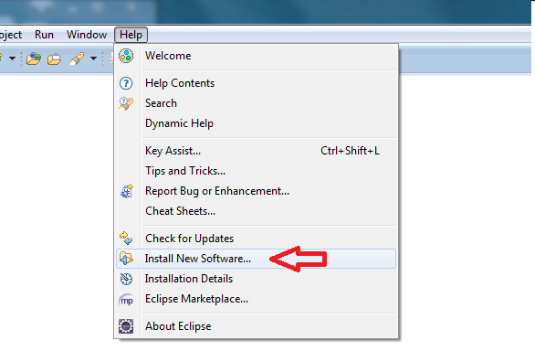

* We want to add a repository so on the next screen click the **Add…** button

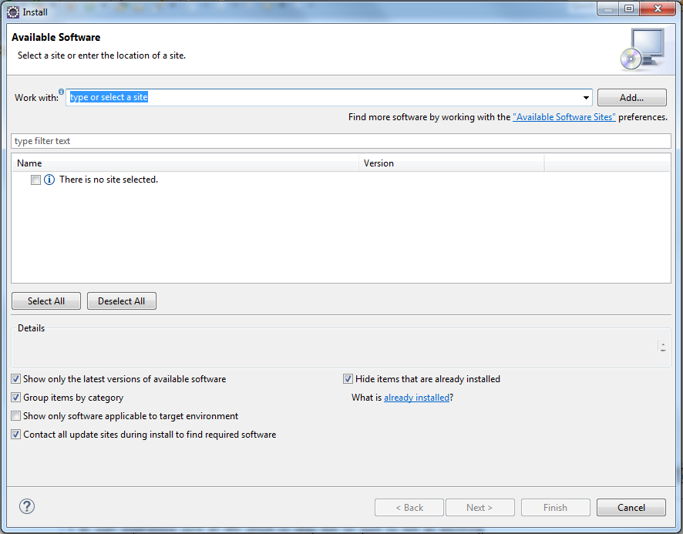

* In the popup fill in the name with **Eclipse CDT** and the location with the link you copied from the Eclipse CDT downloads page.
* Make sure to remove any extra information in the location field that might have been placed **before** the link.
* Click OK

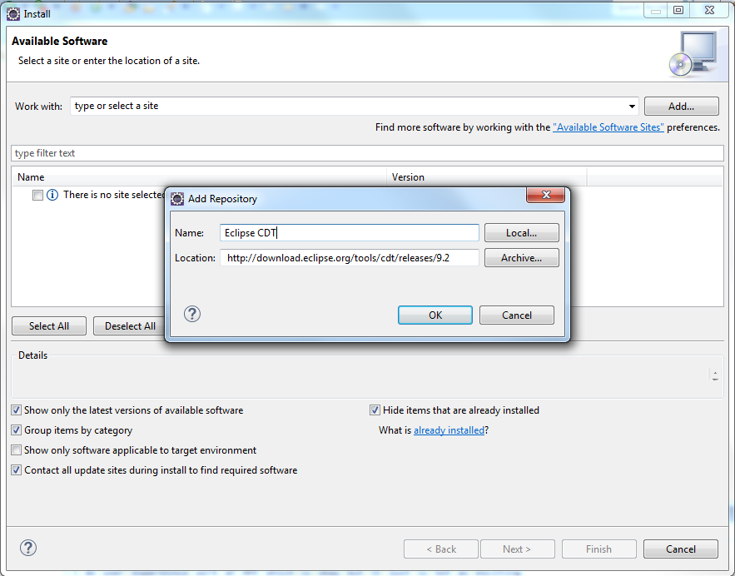

* Next you will see the screen filled in with the CDT features that are available.

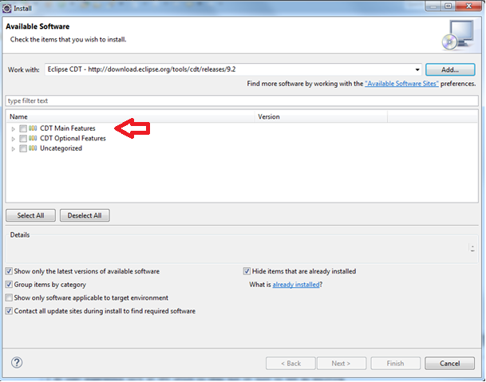

* We want to install all the main features so select **CDT Main Features**
* Click Next

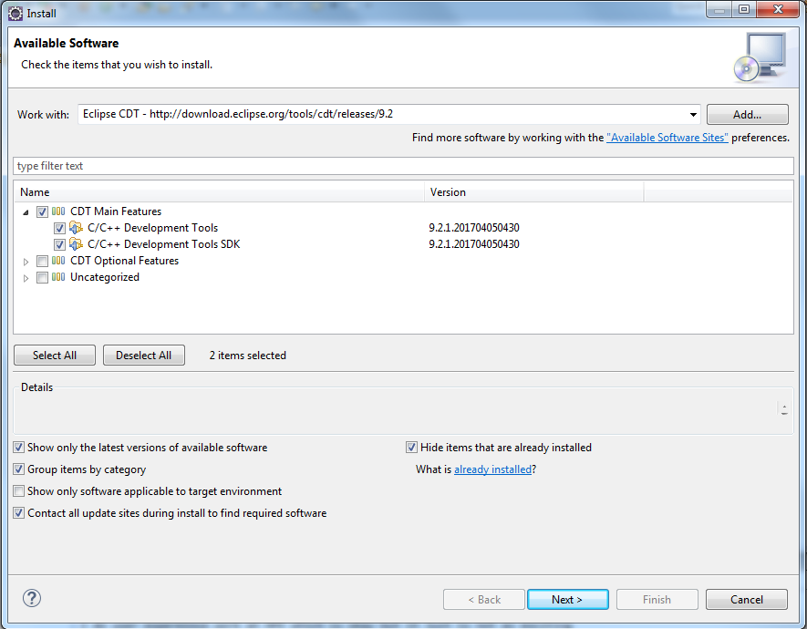

* If you see the following window, leave the radio button they selected and click next
* I saw the screen below because I thought I had Neon installed but I had Luna installed!
* Eclipse is smart enough to know that I didn’t know what version I had! 😊

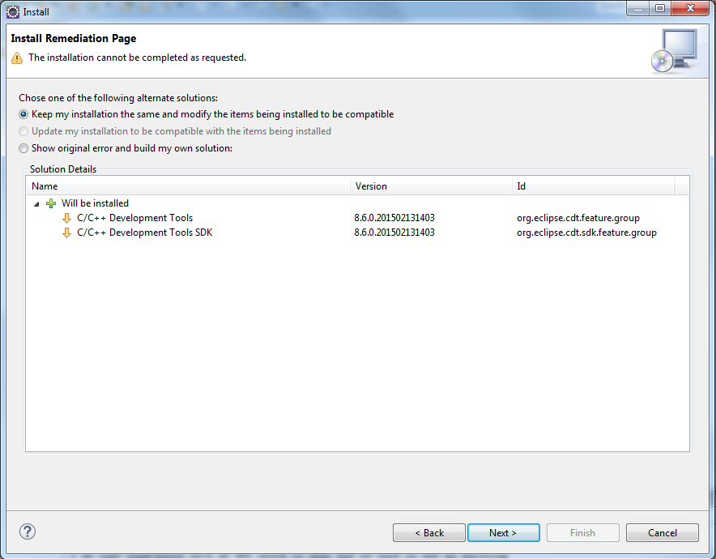

* Accept the license agreement
* Click Finish and installation will begin

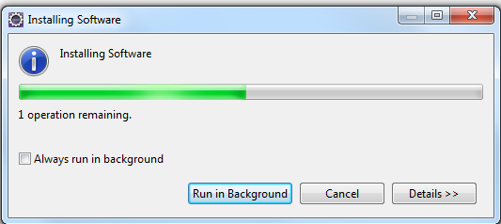

* When everything is complete, restart Eclipse

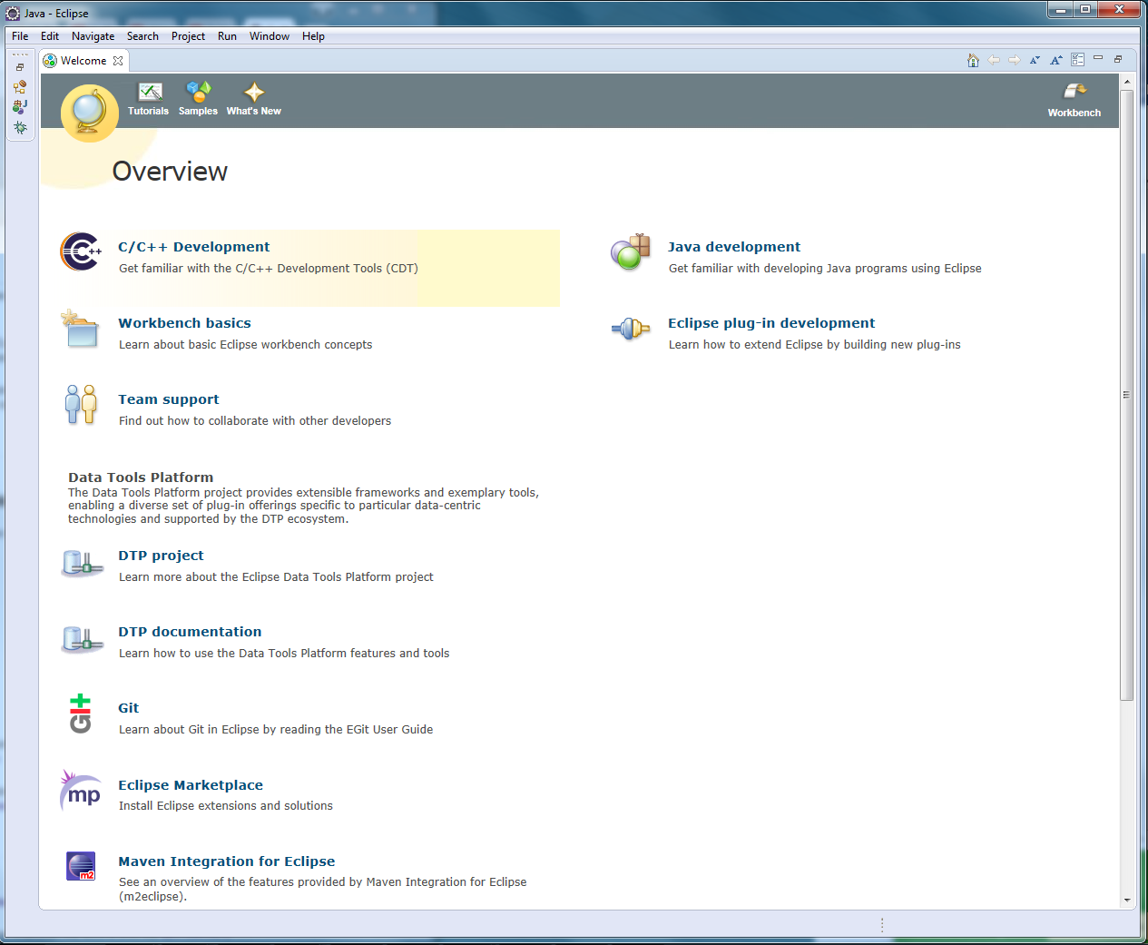

* You should be setup to run and compile C/C++ programs.

Note: You will see a different welcome screen if you setup for just C/C++

